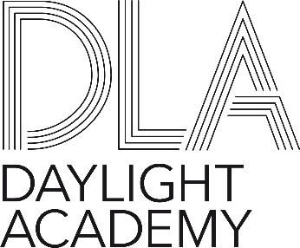

**Project Submission Form**Welcome to the Project Submission Form! This form is designed to let you fill in the necessary details required for the DLA Steering Committee to consider your project. Use the explainers in the tables to fill out the form correctly.

You can also read the [**DLA Project Policy**](https://daylight.academy/wp-content/uploads/2025/07/DLA-Project-Policy_Approved-July-2025.pdf) for further details about how projects work.

|  |  |
| --- | --- |
| **Project title** |  |
| **Goals** | List the goals of your project and provide 100-200 words of context |
| **Disciplines** | List the disciplines that will be used or are needed for this project, highlighting if any are not yet present in the working group. |
| **Outputs** | List the outputs your project aims to provide. |
| **Process** | Describe how you will achieve your goals and outputs. Ideally, using a timeline. |
| **Dissemination plan** | Describe how you want to disseminate the outputs of your project and list specific dissemination targets (for example a journal article, video, workshop, conference lecture, etc. |
| **Lead** | List the names of the leads of your project, the discipline(s) they bring and their affiliation.  *\*Please note that a project must have a DLA member as a lead or co-lead.* |
| **Group members** | List the names of the participants of your project, the discipline(s) they bring and their affiliation. |
| **Budget estimation** | Detail your budget plan and how much funding your project will need/is asking for. Include individual costs and explain what they will be used for. |
| **SDG** | Does your project proposal touch on one or more of the United Nations’ Sustainable Development Goals (SDG)? If so, let us know which one(s).  *\*Please note that your project proposal does not have to align with an SDG.* |
| **DLA Societal Topic** | Let us know if your project proposal is aligned with one of the four broader societal topics that the DLA has set out. These are:  - Daylight versus Urban density  - Daylight & Global Health  - Right to Daylight  - Future Solar Societies  *\*Please note that your project proposal does not have to align with a DLA Societal Topic.* |